8/2/2023

Vidhya Venugopal (8902970)

PROG8400-100-23S-2 1

PROG8400-23S-Sec2-Relational Database Design:

Assignment 8 (Lab 8)

1. Step 1 - Created the main query to fetch the employee sales data from [WonderfulWheelsDW] Database and Tested it by passing the search parameters:A screenshot of a computer

   Description automatically generated

1. Step 2 - Created a main view to fetch the employee sales data and tested it using the search parameters:

1. Step 3 - Created a stored procedure and utilize the above created view and tested the stored procedure by passing the search parameters:

1. Major steps for Report development with the datasets, parameters & default values:

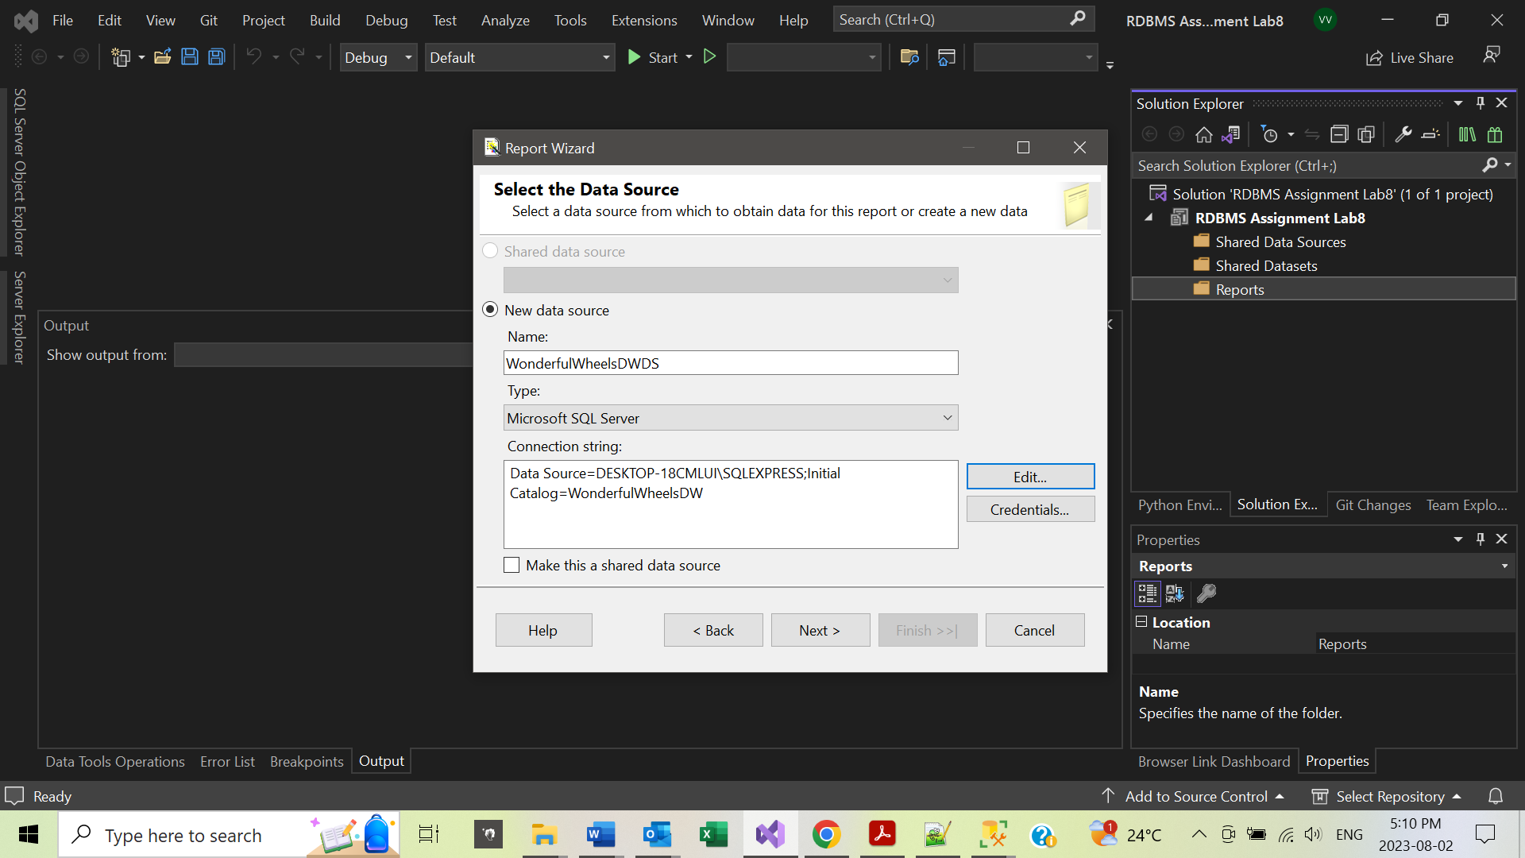

1. Set the datasets, parameters, and default values:

1. Tested the report by not providing any of the search parameters, it returned all the commission employees including who did not sell any cars:

Test Results:



1. Tested the report by providing only the LastName as ‘Spencer’:

Test Result:



1. Tested the report by providing only the Year as ‘2020’ and Month as ‘9’:

Test Result:



1. Displayed power BI dashboard of 3 Visualization:

Exported Visualization:

